A000-AM,C-Taino-Celt-Thunderstone-Steatite-1000 CE

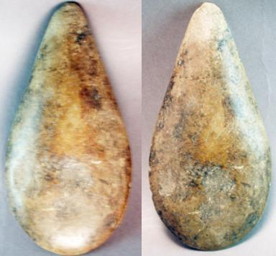

Figs. 1-2. AM,C-Taino-Celt-Thunderstone-Steatite-1000 CE

Case No.: 18

**Accession No.**

**Formal Label:** AM,C-Taino-Celt-Thunderstone-Steatite-1000 CE

**Display Description:**

Individual steatite celts may have been used as currency by the Tainos. This petaloid shaped celt has a deep patina and a few minor chips and nicks . This polished stone tool was taken from a voodoo altar. The rust colored stains indicate sacrificial offerings. This large celt has a deep patina from extensive use.

Although this pre-Columbian artifact originated with the original inhabitants of Haiti,  the Arawak (Taino) or Ciboney, it was adopted as a sacred or magical object by the Africans. This artifact and others were purchased more than ten years ago from one of a number Haitian houngans (Voodoo priests) in the town of Jeremie (Southwestern Haiti) and nearby vicinities while doing my fieldwork. This pre-Columbian stone axe head and was placed upon a Haitian voodoo altar because of its spiritual value as a connection to the African god of Shango. This stone to believed to possess magical powers therefore.

When found in streams and fields they are believed to be the business end of a lightning bolt, hence the name Thunderstone.

**LC Classification: F 1909**

**Date or Time Horizon: 1000 CE**

**Geographical Area: Eastern Hispaniola, Haiti**

**Map:**

**GPS coordinates:**

**Cultural Affiliation:**

**Medium: steatite**

**Dimensions: 6**" x 3" ( 15 cm x  7.5 cm)

**Weight:** 15 ounces  420 g

**Condition:**

**Provenance:**

**Discussion:**

**References:**

**Type of Object:** CELT STONE TOOL

**Ethnic Group:** TAINO, ARAWAK or CIBONEY

**Country of Origin:** HAITI

**Materials:** GREENSTONE

**Approximate Age:** 500+ years old

**Dimensions:**

**Weight:** 15 ounces  420 gs

**Overall Condition:** Used,  very good minor chips

**Additional Information:**This petaloid shaped celt has a deep patina and a few minor chips and nicks . This polished stone tool was taken from a voodoo altar. The rust colored stains indicate sacrificial offerings. This large celt has a deep patina from extensive use.

Although this pre-Columbian artifact originated with the original inhabitants of Haiti,  the Arawak (Taino) or Ciboney, it was adopted as a sacred or magical object by the Africans. This artifact and others were purchased more than ten years ago from one of a number Haitian houngans (Voodoo priests) in the town of Jeremie (Southwestern Haiti) and nearby vicinities while doing my fieldwork. This pre-Columbian stone axe head and was placed upon a Haitian voodoo altar because of its spiritual value as a connection to the African god of Shango. This stone to believed to possess magical powers therefore.

When found in streams and fields they are believed to be the business end of a lightning bolt, hence the name Thunderstone.